WS 2025/26

Lab course: Human Robot Interaction

Task 1: ROS Introduction and Robot Motion

Chair of Autonomous Systems and Mechatronics
Friedrich-Alexander-Universität Erlangen-Nürnberg

TEAM 1 :
Velayudhan Aravindakshan - ju08rufe
Akhilan David Karthikeyan - ug39owys
Wei Zhang - jo07wuwe

Exercise 1

The Spyder Integrated Development Environment was explored, and the mentioned example codes were executed, with modifications made to rectify the error and complete the program execution.

Exercise 2

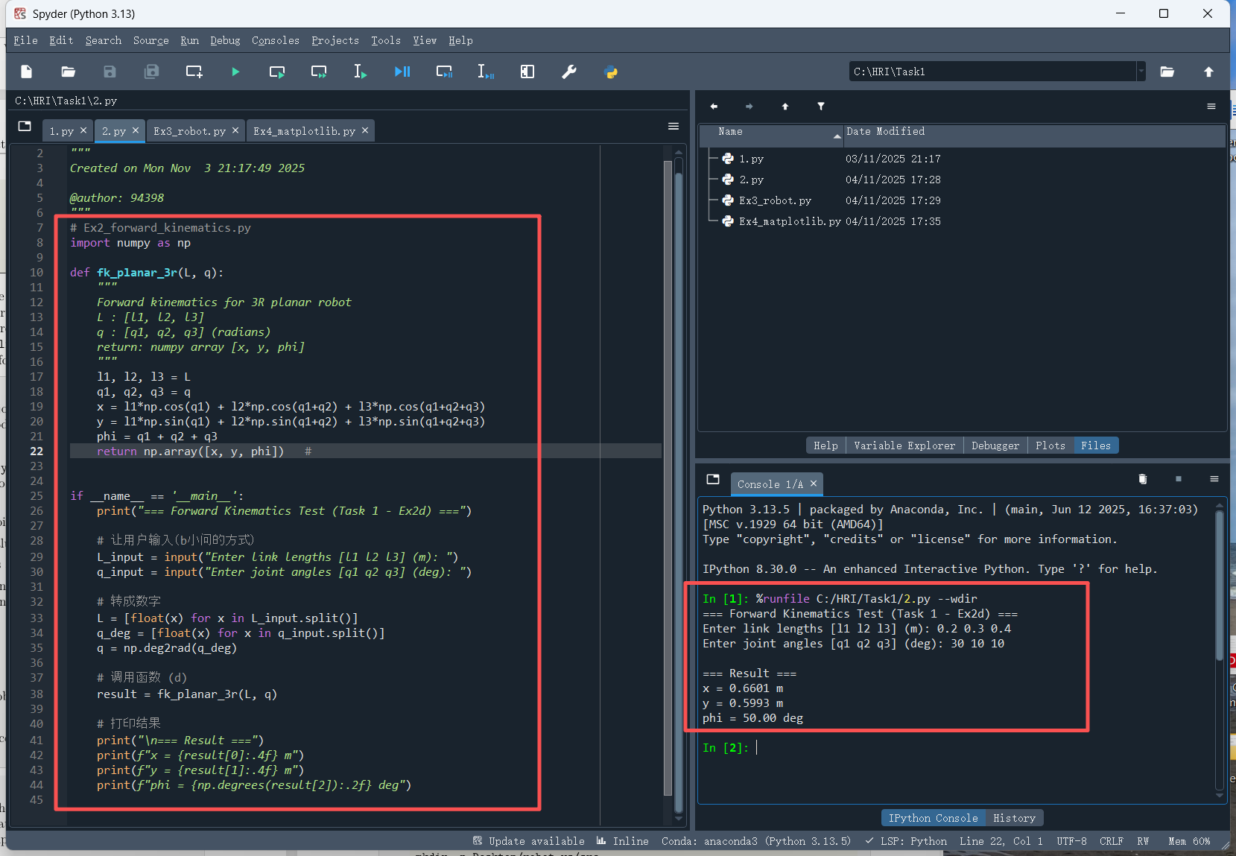

The forward kinematics of the robot is calculated as 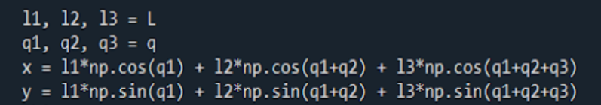
Where l1,l2 and l3 are the link lengths. q1, q2 and q3 are the angles.

The function with the name “main” has an input function which takes the joint angles and link length. We have implemented all the logic within the main calling function.

Exercise 3

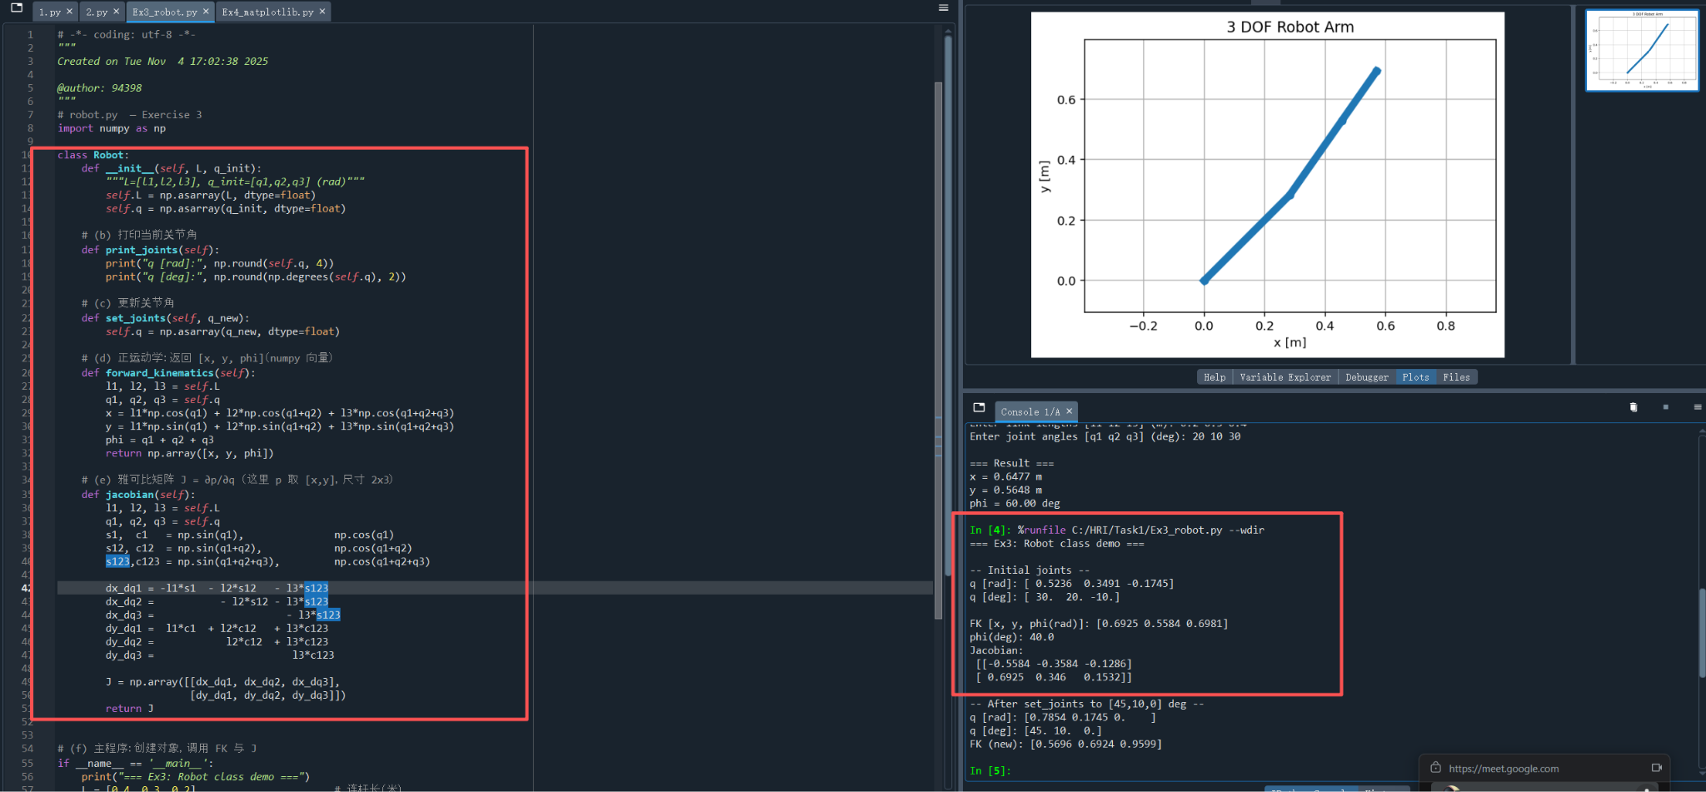
The screenshot describes the class Robot, which includes functions such as init (a constructor for predefining the joint vector to an arbitrary value), print_joints (a function that prints the current joint values), set_joints (a function that changes the joint values to the passed values), and others.

Exercise 5

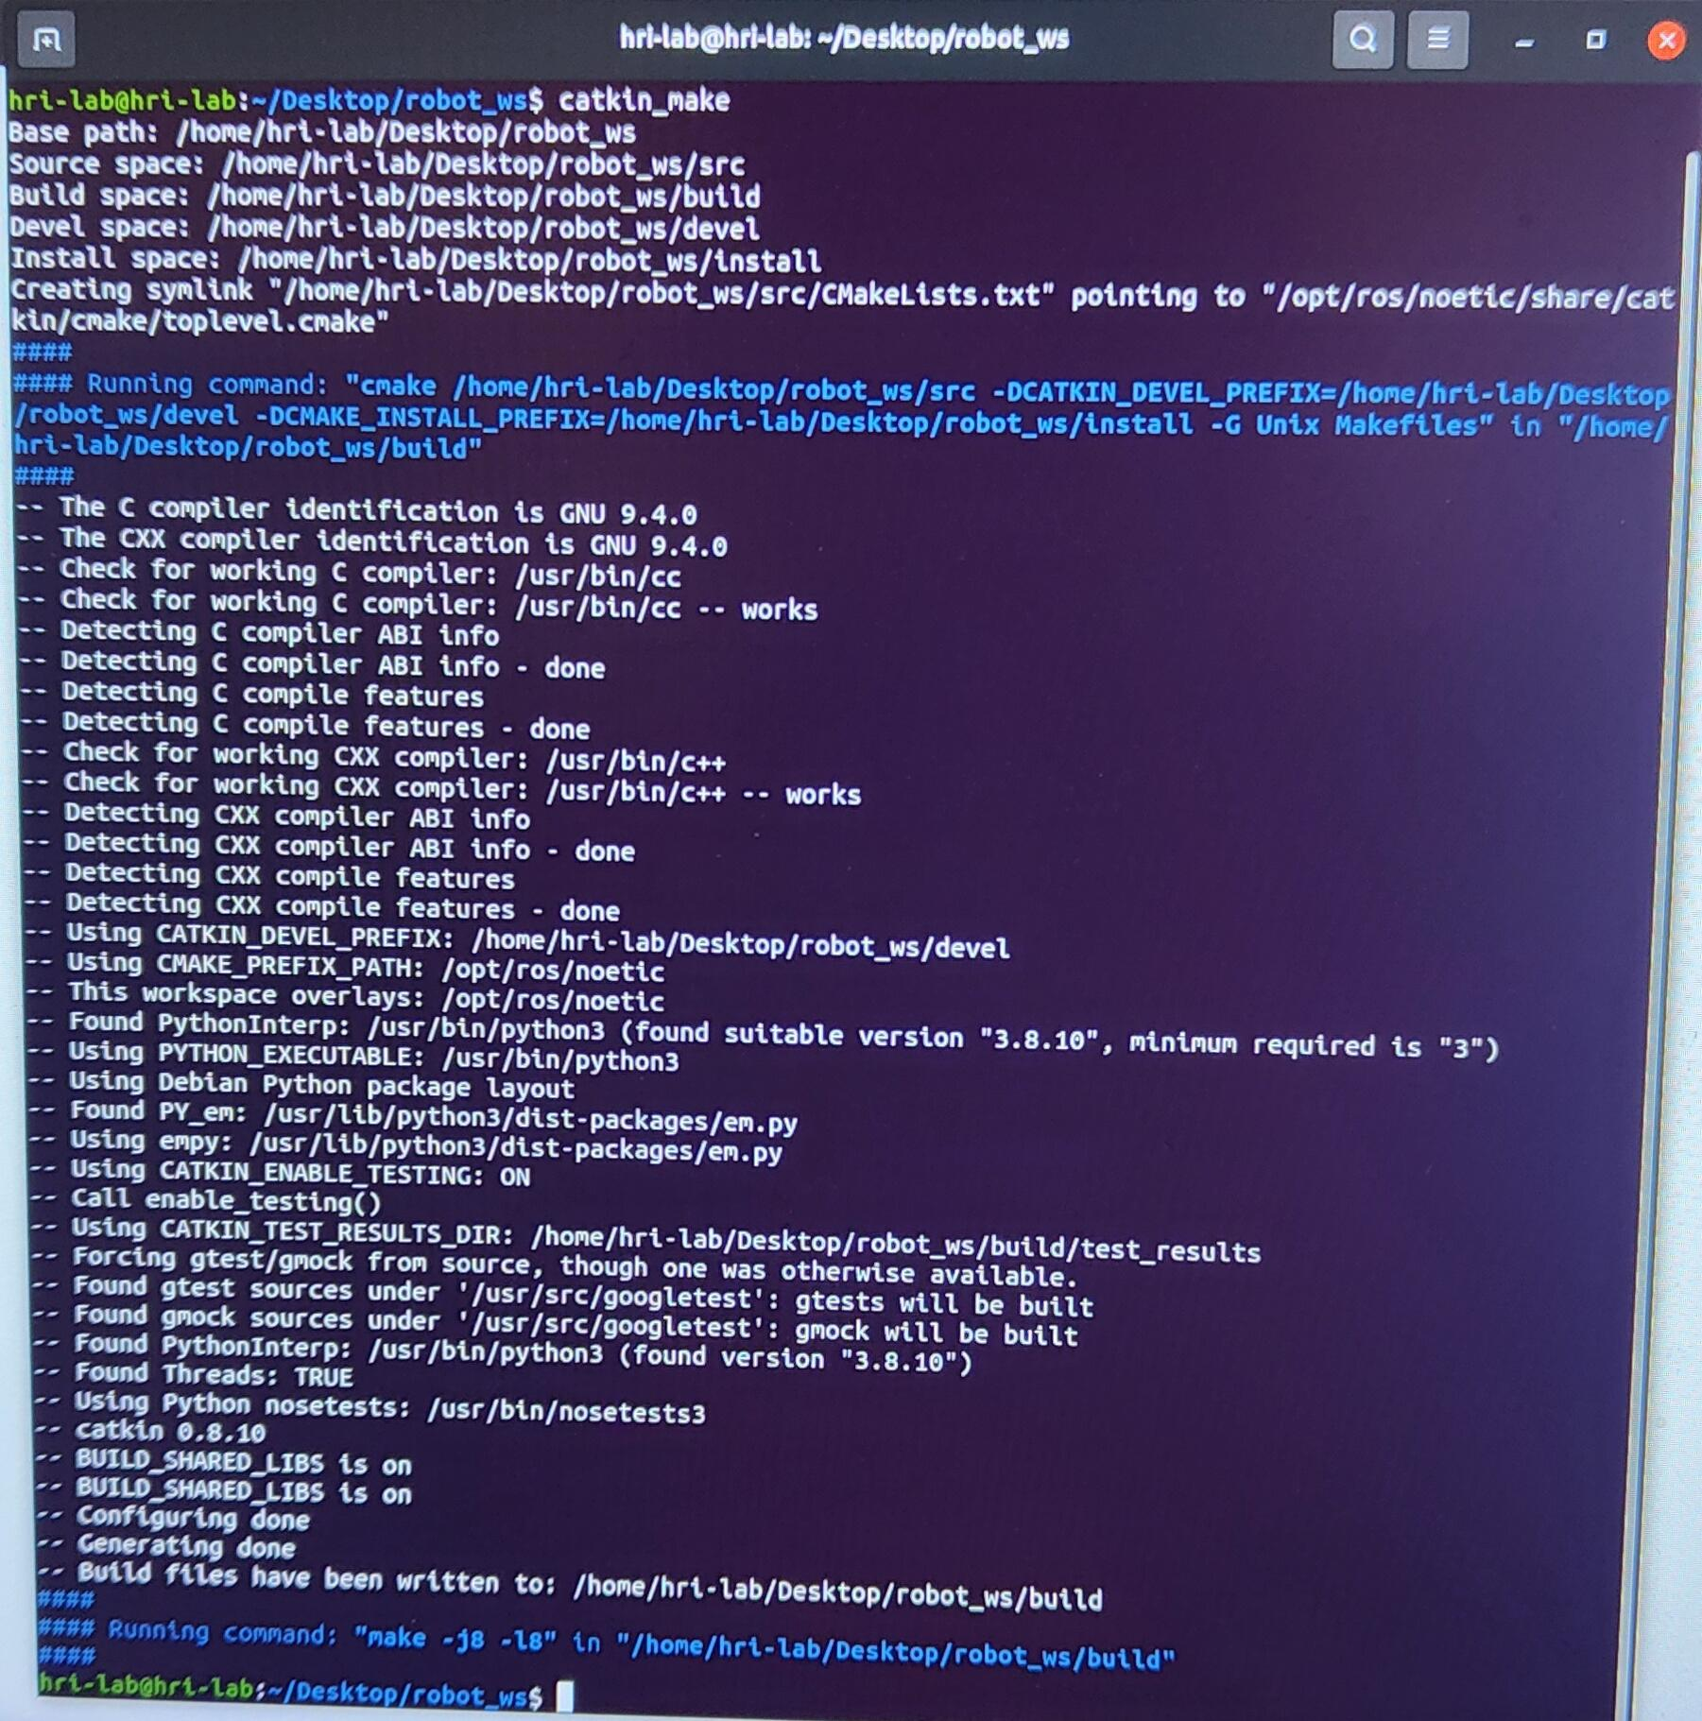

The workspace creation is been done based on the commands provided and the process executed without any errors.

Exercise 6

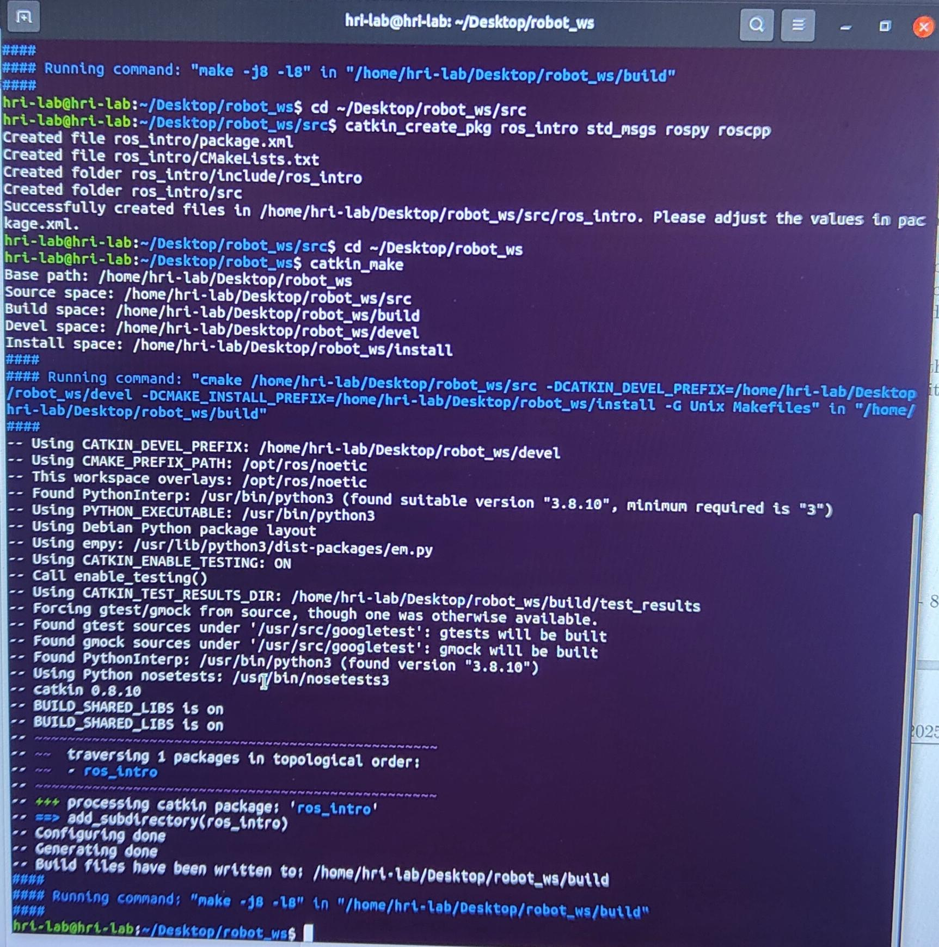

Modifications on the source file by creating a package named ros_intro.

Exercise 7

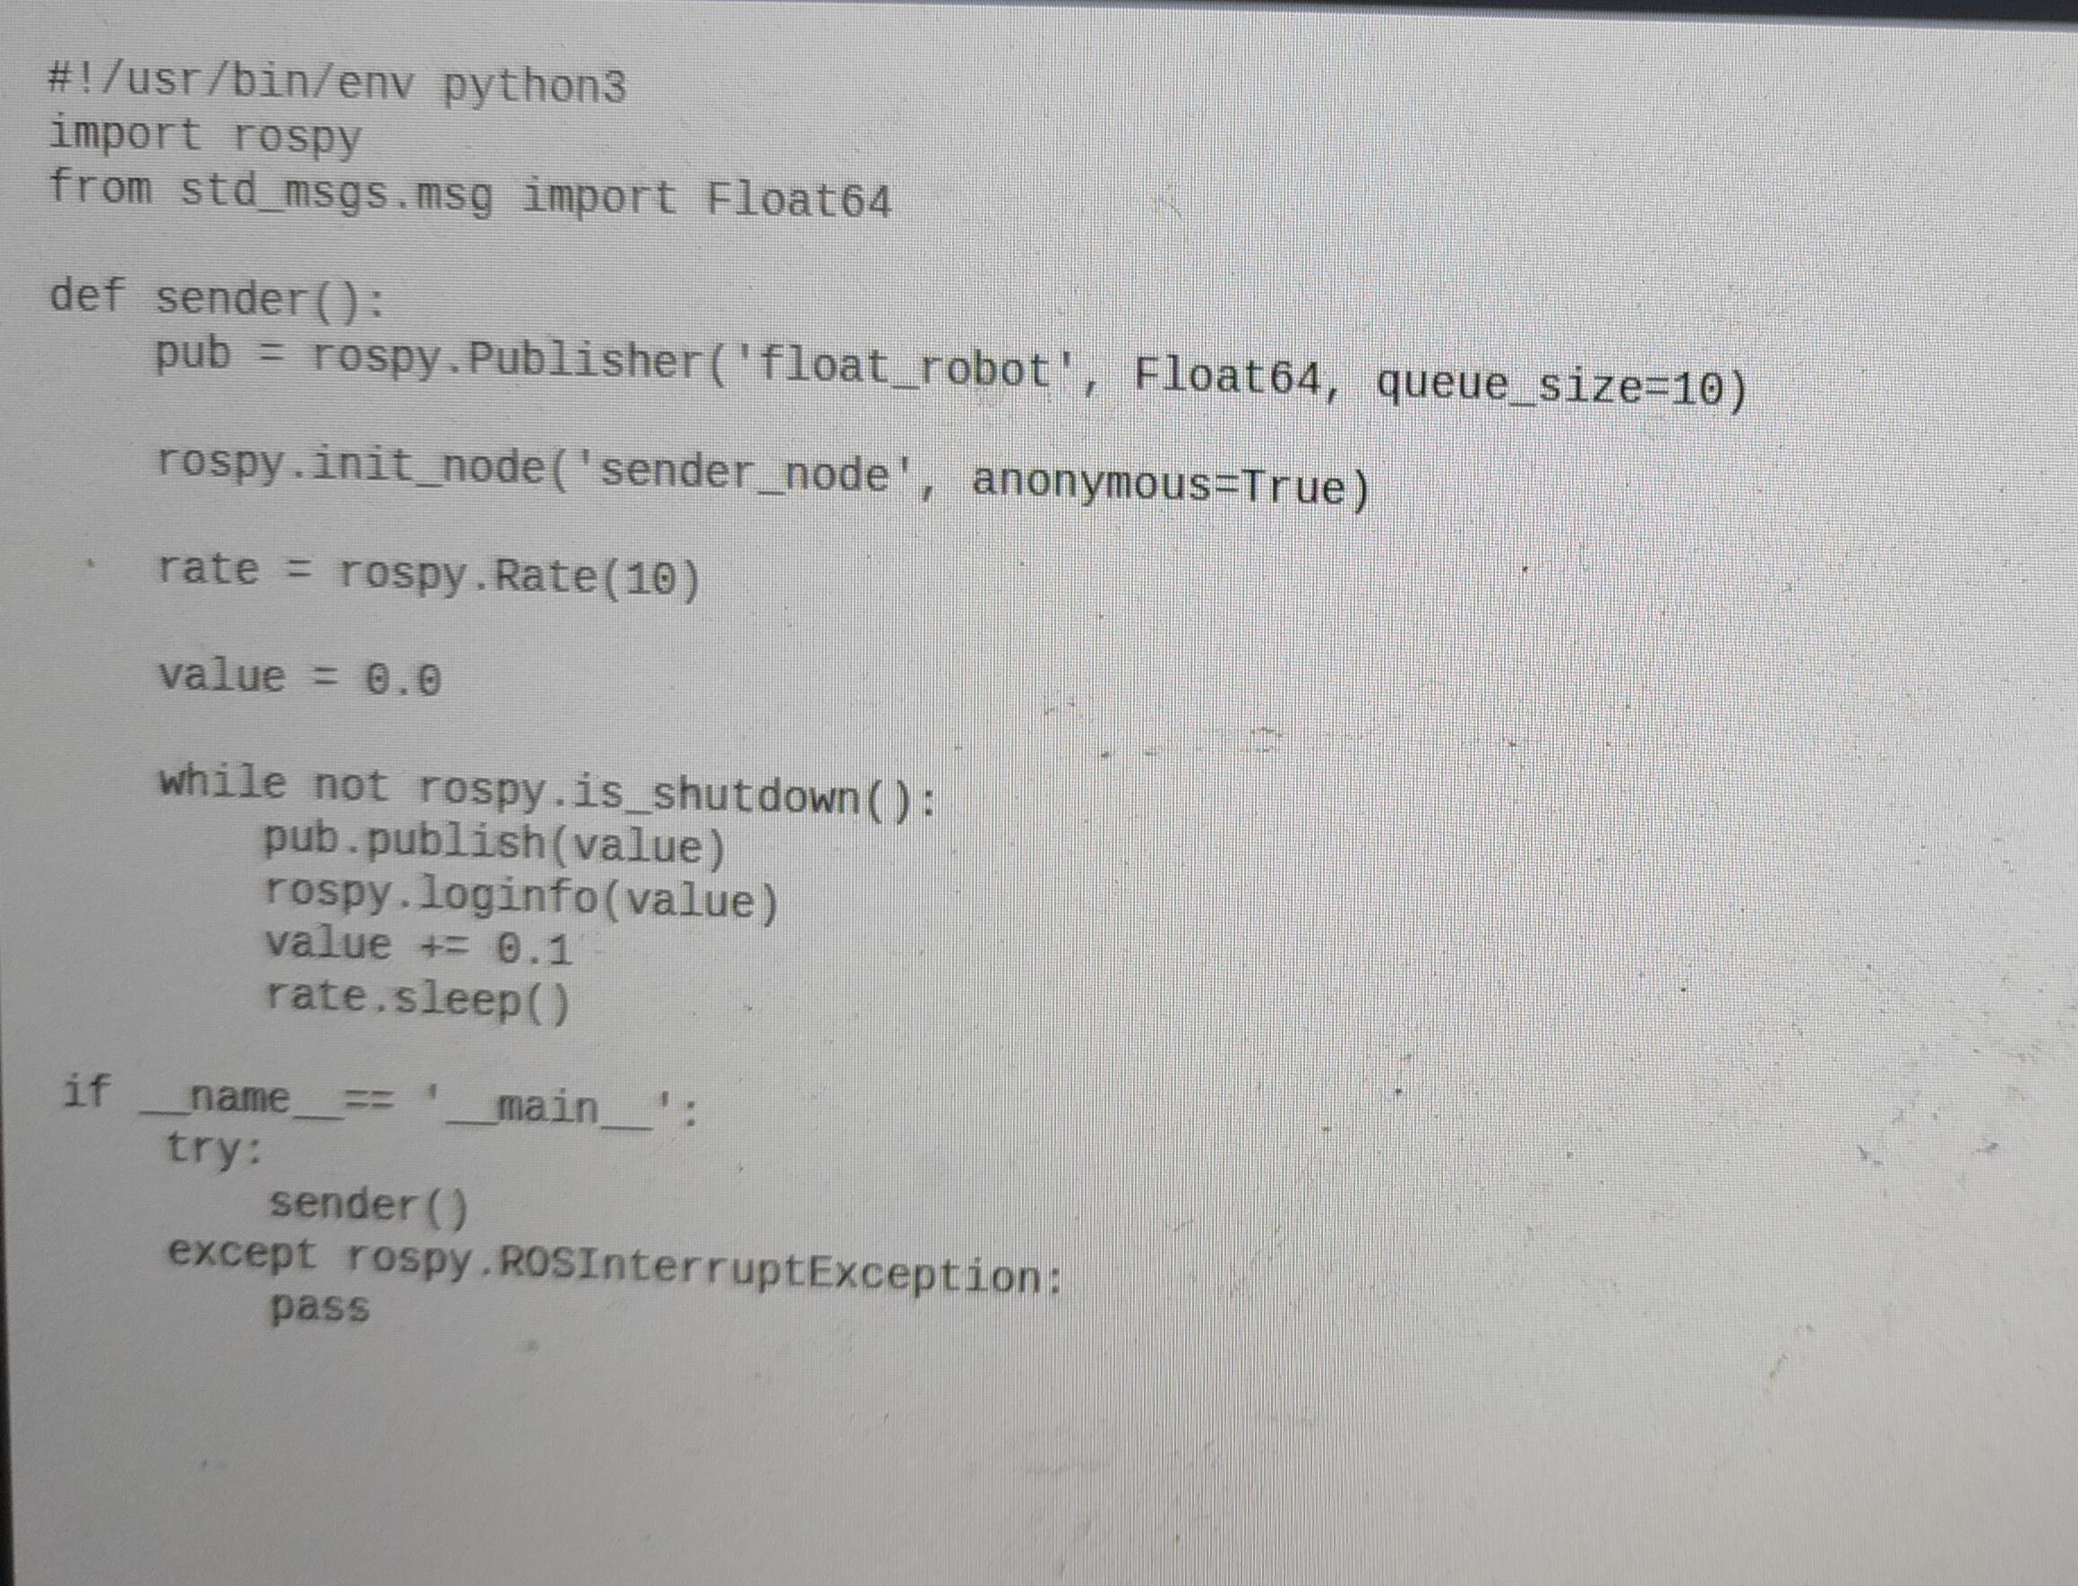

The send float function is been defined based on the exercise instruction and executed successfully without bugs

Exercise 8
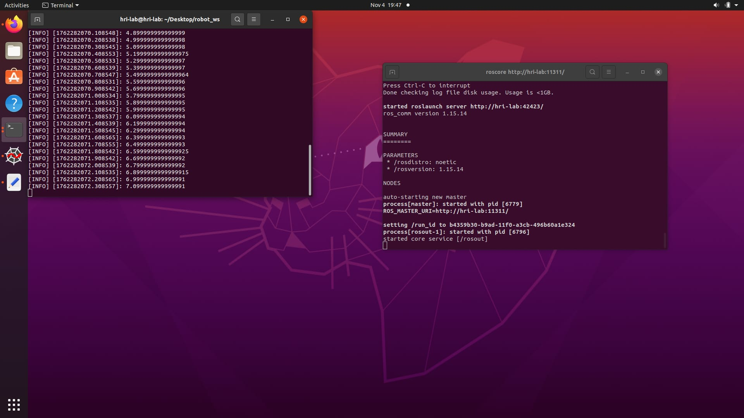

Exercise9
